The Bit In-Between

Malcolm Imhoff at Snods Edge March 2026
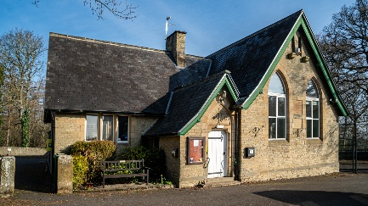
When I arrived at Snods Edge to help set up for the NAVGroup Audio Visual day, the sun was shining brightly, not a cloud in the sky. Birds welcomed the first day of spring with cheerful song. It was the sort of weather that usually tempts you outdoors, yet we were preparing to spend the day inside a darkened hall. No matter—today, we had AV royalty in our midst: Malcolm Imhoff FRPS FACI(M) AV-EFIAP, our fantastic guest speaker. We also had fourteen of our own AV programmes lined up to watch.
Stepping into the old school hall, we were immediately struck by the fresh new paint job that left the space looking pristine. The early birds among us started arranging chairs and inspecting the high-tech equipment now installed. At first, there was no sound. It took a few minutes before we realised that, to paint the walls, the decorators had removed the huge speakers and forgotten to return them. Fortunately, the committee had anticipated such mishaps and brought their own AV equipment in the back of a car. After a brief debate, Patrick Johnston our Treasurer and Techie, selected a suitable set of speakers and soon had everything working.
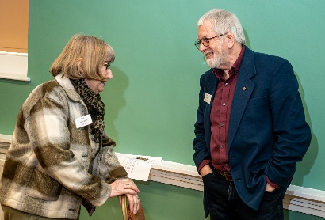
Despite a slightly stressful set-up, our twenty-four delegates soon settled in, and the event began right on time. Val Johnston, our Chairlady, had scheduled seven members' AV presentations before the coffee break. There’s no need to list each one, but the variety was impressive - ranging from a thoroughly researched and captivating travelogue of the Holy Island of Lindisfarne to a masterful AV of macro images capturing tiny insects. We enjoyed an experimental programme about ten-pin bowling, a fascinating record of how to build a camera from scratch, a travelogue through Germany in 1979 brought to life via old slides, a Scottish take on the Bayeux Tapestry, and a series of breathtaking wildlife images set to music. Malcolm Imhoff offered constructive and insightful feedback on every programme, which the authors gratefully received.
1 our Chairperson Val Johnston chats to Malcolm Imhoff
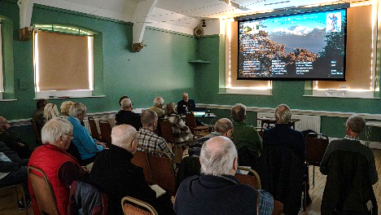
After coffee, Malcolm Imhoff truly warmed up the proceedings—both figuratively and literally, as we also tracked down the thermostat to take the chill off the hall. Malcolm’s presentation featured his award-winning audio-visual works themed around mountains. One particularly memorable sequence transported us to the snow-capped peaks of the Alps, where Malcolm recounted a harrowing ascent in pre-dawn darkness. His images captured the golden light breaking over jagged ridges, with clouds swirling far below—a scene both awe-inspiring and humbling. His storytelling made us feel as if we, too, were clinging to the mountainside, breathing in the thin, crisp air. It was the closest many of us would ever come to such heights, short of being in an aeroplane.
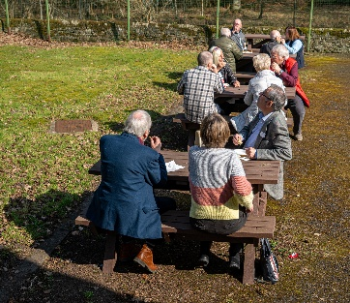
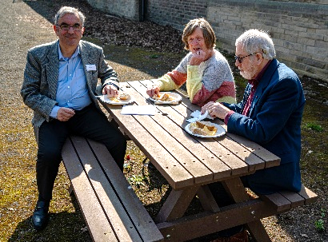
Lunch, often just a necessary pause, was a true delight on this occasion. The beautiful weather and the recently constructed outdoor seating area turned lunchtime into a very pleasant interlude. With conversations flowing easily in the sunshine.
2 Our Secretary David Niman lunches with Malcom and Josie
After lunch, we returned to the hall and once again scaled metaphorical heights with Malcolm. This time, he explained the preparations and mindset required for an epic climb, sharing anecdotes about the physical and mental challenges he had faced. His next AV presentation lifted us above the cloud line, plunging us into a world of dramatic vistas and dizzying perspectives. The combination of stunning visuals and Malcolm's passionate narration left us exhilarated and inspired—somewhat breathless, both physically and artistically.
3. The recently created outdoor eating area
Unfortunately, the day took an unexpected turn when a medical emergency arose in the hall. Swift action from attendees ensured that the person received prompt care—several members coordinated to call for assistance, while others offered support and comfort. The atmosphere was tense during the anxious hour that followed, but everyone rallied together until it was clear the situation was under control. Thankfully, the outcome was positive, and we could all breathe a sigh of relief. Malcolm, ever calm and compassionate, was on hand to reassure those present and became a hero in every sense of the word.
It was an eventful day—unusual at the start and worrying at the end—but in between, it was filled with learning, inspiration, and camaraderie. A memorable day by every measure.
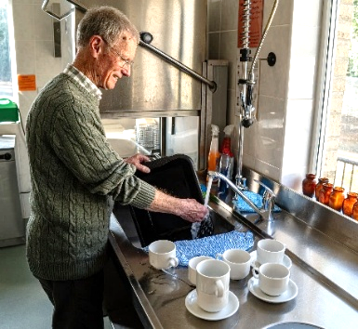
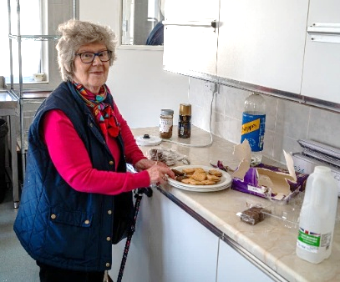
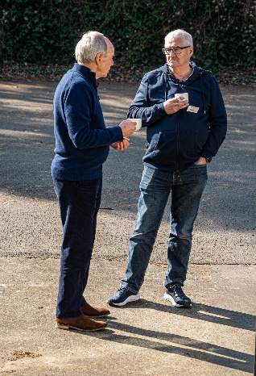
Roin Henry March 2026
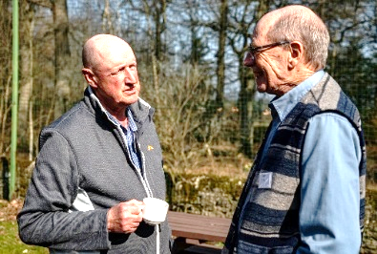
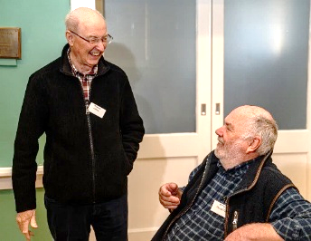
4 Richard and Stewart have an oppinion!
6 Oh to be on the NAVGroup committee!

5 Kath takes the biscuit(s)

